1. Create table

create table books

(

book_id int not null primary key,

book_title char(100) not null,

book_author char(30) not null,

book_ISBN char(20) not null,

book_publisher char(45) not null,

book_year_of_publish int not null,

book_edition nvarchar(15),

book_volume nvarchar(10),

book_qty int not null,

book_short_desc char(100) not null,

book_location nvarchar(25) not null,

book_is_active bit default 1

);

1. Insert/Add new user

insert into users (library_barcode,full_name,address,contact_no,email_id,payment,user_name,password,user_role_id)

values

('123456','Kishan Patel','999 Summit Ave NY 10175','+201-273-6890','kishan@nyit.edu','4548 4582 4582 4569 53','kpatel','kp123','1');

1. Update user

update users

set contact_no = '+201-277-6890'

where library_id = 7

1. Add new media(book)

insert into [dbo].[books] values

('Concept of Prog lang','Robert W. Sebesta','978-93-325-1887-2','Pearson Education Inc','2015','2nd','1','5','Programminfg language evolution and OOPs concepts','F2/CS/S4',1)

1. Add new reading rooms

insert into reading_rooms

(room_name,room_location)

values

('F101','first floor - RoomNo-F101'),

('F102','first floor - RoomNo-F102'),

('S101','second floor - RoomNo-S101'),

('T101','third floor - RoomNo-T101'),

('T102','third floor - RoomNo-T102');

Room reservation for 2 hours

INSERT INTO room_reservation

VALUES(GETDATE(), DATEADD(hh, 2, GETDATE()),1,1)

Report - Search for any room,room reservation end tine and reserved by user

select rr.room_reservation_end_datetime,r.room_name,u.full_name

from room_reservation rr,reading_rooms r,users u

where rr.room_id = r.room_id and

rr.room_reservation_id = u.user_library_id

renew room

update room_reservation

set room_reservation_start_datetime = room_reservation_end_datetime ,room_reservation_end_datetime = DATEADD(hh, 2, room_reservation_end_datetime);

Stored procedure for unique user

CREATE PROCEDURE print_unique_user_entry

-- Add the parameters for the stored procedure here

@print_user_id int,

@print_pages int,

@print_charges decimal

AS

BEGIN

IF NOT EXISTS (SELECT * FROM prints

WHERE print_user_id = @print_user_id)

BEGIN

INSERT INTO prints (print_pages, print_charges, print_user_id)

VALUES (@print_pages, @print_charges,@print_user_id)

END

IF EXISTS (SELECT * FROM prints

WHERE print_user_id = @print_user_id)

BEGIN

update prints set print_pages = @print_pages

END

END

GO

* Damage media

UPDATE BOOKS set book_is_active = 0

where book_barcode = 'B0005'

book search

book bar code

select * from books

where book_is_active = 1 and book_barcode = 'B0001'

author and book title

select * from books

where book_is_active = 1 and book_title like 'con%' and book_author IN ('Robert W. Sebesta','danial%')

author,book title and book barcode

select * from books

where book_is_active = 1 and book_title like 'con%' and book_author IN ('Robert W. Sebesta','danial') and book_barcode = 'B0001'

checkout book and make book not in quantity

insert into checkout(chk_date,chk_exp_rtn_dt,chk_rtn_dt,chk_user_id,chk_fees,book_barcode,video_barcode,device_barcode,journals_barcode)

values (GETDATE(),DATEADD(dd, 20, GETDATE()),'',2,0.00,1,NULL ,NULL ,NULL);

update books set book_is_active = 0 where book_id = 2

update checkout set chk_rtn_dt = '2017-06-20' , [chk_no_of_days] = DATEDIFF(day,chk_date,chk_rtn_dt),chk_fees = [chk_no_of_days] * 1.00

where checkout.

update books set book_is_active = 1 where book_id = 3

fee report

select * from checkout where chk_no_of_days > 1

book fine report and over due media report

select u.full_name,b.book_title ,c.chk_fees as book_fine,

c.chk_exp_rtn_dt as exp_return_date,c.chk_rtn_dt as actual_return_date

from checkout c , users u , books b

where c.chk_user_id = u.user_library_id and

c.book_barcode = b.book_id and

chk_exp_rtn_dt < chk_rtn_dt

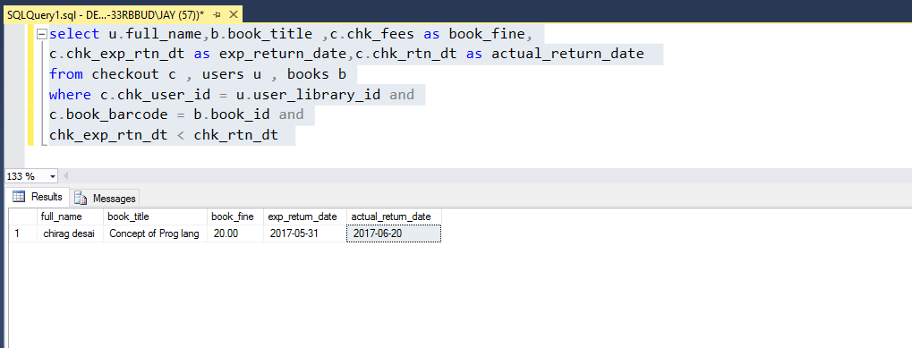

Media damage report

select book_title,book_author,book_ISBN,book_location

from books

where book_is_active = 0

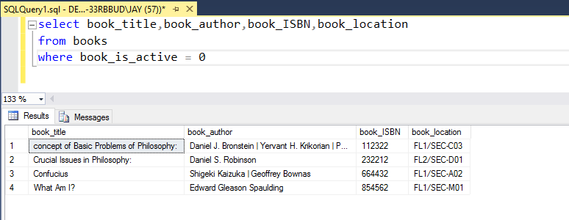

Function for barcode generate

USE [library_management]

GO

/****** Object: UserDefinedFunction [dbo].[device_barcode] Script Date: 5/12/2017 10:30:02 PM ******/

SET ANSI_NULLS ON

GO

SET QUOTED_IDENTIFIER ON

GO

-- =============================================

-- Author: <Author,,Name>

-- Create date: <Create Date,,>

-- Description: <Description,,>

-- =============================================

IN this Function this will generate barcode like D00001 for devices ,for books B00001,

for videos V00001 and for journals J00001

ALTER function [dbo].[device_barcode] (@id int)

returns char(5)

as

begin

return 'D' + right('0000' + convert(varchar(10), @id), 4) //

end